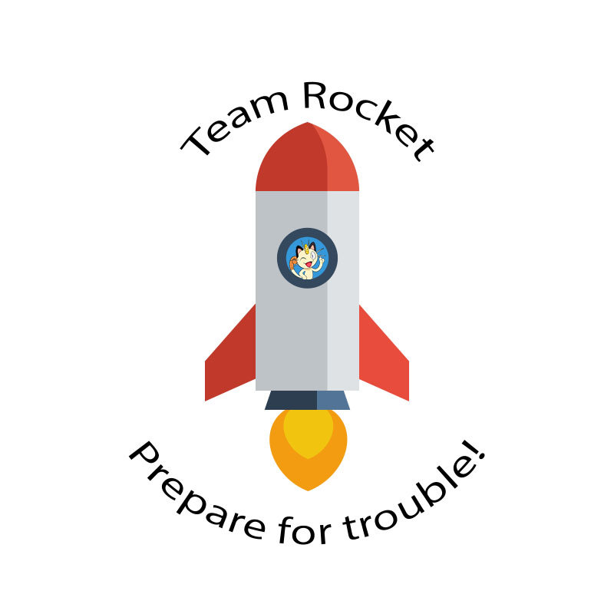

Team Rocket’s

Deployment Plan

1. Introduction

Our team must investigate different deployment options to best use our available resources. We have decided that starting our app as a mobile android app is the best decision. Any deployments to other platforms would depend on the success of our mobile app. The app would start out being free, with ads and in-app purchases the primary source of revenue. A paid version of the app would remove the ads from our game, which would also bring in more revenue. Different platforms introduce different advantages and disadvantages to our current business model. To find the best use of our resources, we must research our options.

II. App Store Costs

The available app stores we could launch our game on are Google Play, the Apple app store, the Amazon app store, and the Windows store. Google Play offers a one-time fee of $25, to publish an app to their store, with a revenue split of 85-15, meaning 85% of the revenue goes to the developer. The Apple app store offers an annual fee of $99/year, with a revenue split of 85-15 also. Amazon’s app store has no publishing fee, but demands a revenue split of 85-15, and also has significantly lower traffic than Google play or the Apple app store. According to Statista, in 2017, Google Play had 2.8 million downloadable apps, while the Amazon app store only had 600,000. This translates directly to traffic on the app stores because users have all their apps in the same location. The Windows store has a similar situation. It demands an 85-15 revenue split, but boasts a 95-5 revenue split if the app is not a game, and is specially registered with Microsoft. Traffic on the Windows store is only marginally better than the Amazon app store, with 669,000 total downloadable apps, according to Statista in 2017. “Unfortunately, you don’t get your money immediately when you make a sale”, says TechRepublic, referring to the fact that most of these platforms hold your money for a certain period of time. The Google Play store is the best at delivering on time, paying just a few days after the end of the month, while many other companies will pay 30 days after the end of the month. Google’s store also has no minimum on delivering payment, meaning any revenue, no matter how small, is delivered.

III. Cost of Distribution to Other Platforms

Provided that our app becomes popular and gains sizeable revenue, it may be worth expanding to other platforms, such as Xbox Live or to an online domain. According to an article published by The Verge, costs to deploy our game to Xbox Live would cost between $20-100. This expansion would enable our app to reach a larger audience, although, the article by The Verge claims that deploying our game to Xbox Live would place it in a segmented portion of the Xbox Live store, depriving it of exposure, unless we applied to the ID@Xbox program. If we were to deploy our game to Xbox Live, we would most likely also apply to this program, to ensure that our game gets as much exposure as possible. Along with the Xbox Live launch, we would also want to print physical disks to supplement this. The cost of these disks is between 50 cents and $3 each, depending on the quantity of disks ordered. A tentative estimate would be ordering 5000 disks at $1 apiece plus any shipping costs, which would add about $5100 to our total cost of deployment. An expansion to the web requires a domain, whether it is hosted by our team, or we pay someone else to host. The cost to hold a domain is around $15/year on average.

IV. Convention Costs

Conventions are a good way to learn how to develop better content and become better software developers, so it would be beneficial for my team to attend these conferences. Some conferences are free, and others cater to a specific type of software development. FOSDEM is a massive annual conference hosted in Brussels with around 450 events, caters to all types of software engineers, and requires no entry fee. The only major cost would be the plane tickets to Brussels. The Software Architecture Conference is another large conference, hosted in New York City, catering to all aspects of software development, with entry fees ranging from $1,595 to $2,345. Some of these conferences are relatively easy to attend, while others require a steep entry fee or executive business status.

V. Summary of Costs

|  |  |  |
| --- | --- | --- |
| Method of Deployment | Cost | Revenue Split |
| Google Play store | $25 | 85-15 |
| Apple app store | $99/year | 85-15 |
| Amazon app store | $0 | 85-15 |
| Windows Store | $99 | 85-151 |
| Xbox Live | $20-100 | N/A |
| Disk Distribution | $50002 | N/A |
| Web Domain Host | $15/year | N/A |

1 – The Windows Store also offers a 95-5 revenue split, but the app cannot be a game, and must be specially registered with Microsoft

2. – This excludes any shipping costs

**Comparing Conventions**

|  |  |  |
| --- | --- | --- |
| Name of Convention | Location | Entry Cost |
| FOSDEM | Brussels, Belgium | $0 |
| Software Architecture Conference | New York City, New York, USA | $1,595 - $2,345 |
| DeveloperWeek | Oakland, California, USA | $495 - $1,495 |
| QCon London | London, UK | $1,899 - $2,416 |
| Strata Data Conference | San Francisco, California, USA | $1,445 - $2,245 |
| Average Cost | | $1,393.50 |

VI. Conclusion

Based on our research on the cost of deployment, we have decided that a launch on the Google Play store would be the best course of action. Additionally, if our app becomes popular, then a launch the Apple app store may be profitable. The Amazon app store would be the next best deployment option because of the lack of a publishing fee, but the exposure that the app would get would be significantly less than the Apple app store or if our game was deployed on Xbox Live. If deployed on Xbox Live, our app would get more exposure, but at the cost of a similar publishing fee to Apple’s app store, and the fact that in order to get the maximum exposure, you must apply to the ID@Xbox program. Otherwise, our app would be stuck in a segmented part of the Xbox Live store. Our expenses would also increase with needing to order physical disks to support the Xbox release. Finally, if we wanted to expand our game to the web, it would only cost $15/year, but may not get enough traffic, unless we invested heavily in advertising.

**Works Cited**

“How Much Does CD or DVD Packaging Cost? - CostHelper.com.” *CostHelper*, 2019, smallbusiness.costhelper.com/cd-dvd-packaging.html.

Statt, Nick. “Microsoft Now Lets Anyone Create and Publish Xbox Games.” *The Verge*, The Verge, 2 Mar. 2017, www.theverge.com/2017/3/1/14784684/microsoft-xbox-one-windows-10-indie-game-development.

Crabb, Kristin. “How Much Does a Domain Name Cost?” *Domain.com | Blog*, 18 Jan. 2019, www.domain.com/blog/2018/09/13/how-much-does-a-domain-name-cost/.

Mackenzie, Tim. “App Store Fees, Percentages, and Payouts: What Developers Need to Know.” *TechRepublic*, 7 May 2012, www.techrepublic.com/blog/software-engineer/app-store-fees-percentages-and-payouts-what-developers-need-to-know/.

Price, Dan. “Google Play vs. Amazon Appstore: Which Is Better?” *MakeUseOf*, 21 Apr. 2017, www.makeuseof.com/tag/google-play-vs-amazon-appstore-which-is-better-si/.

Jr, John P. Mello. “The Best Software Engineering Conferences of 2019.” *TechBeacon*, TechBeacon, 1 Apr. 2019, techbeacon.com/app-dev-testing/best-software-engineering-conferences-2019.